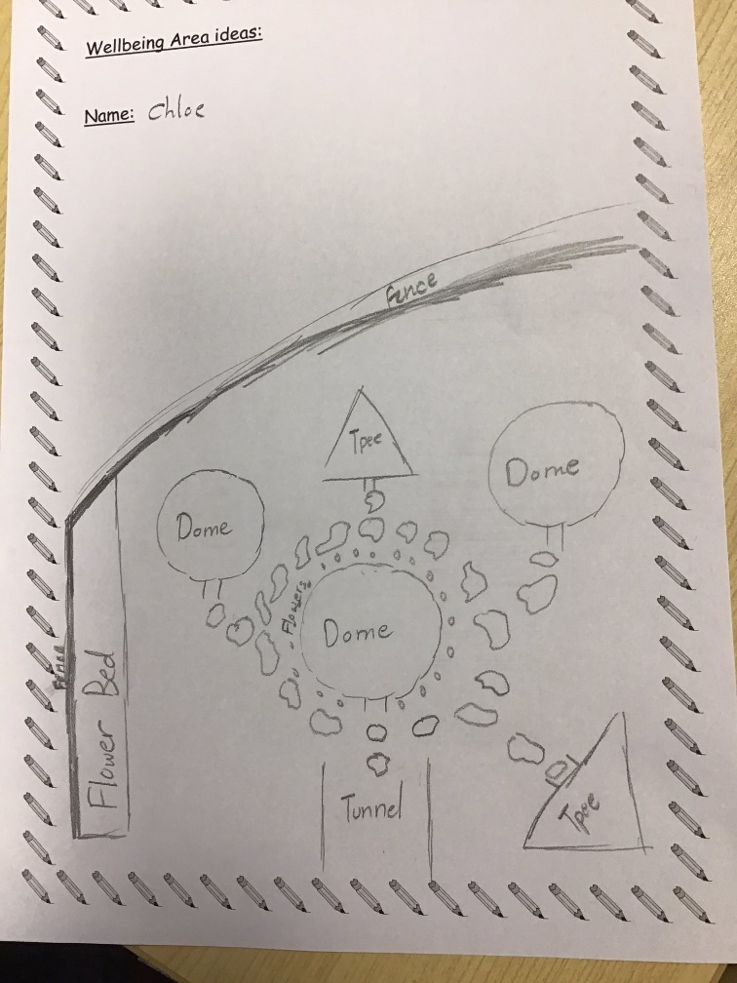
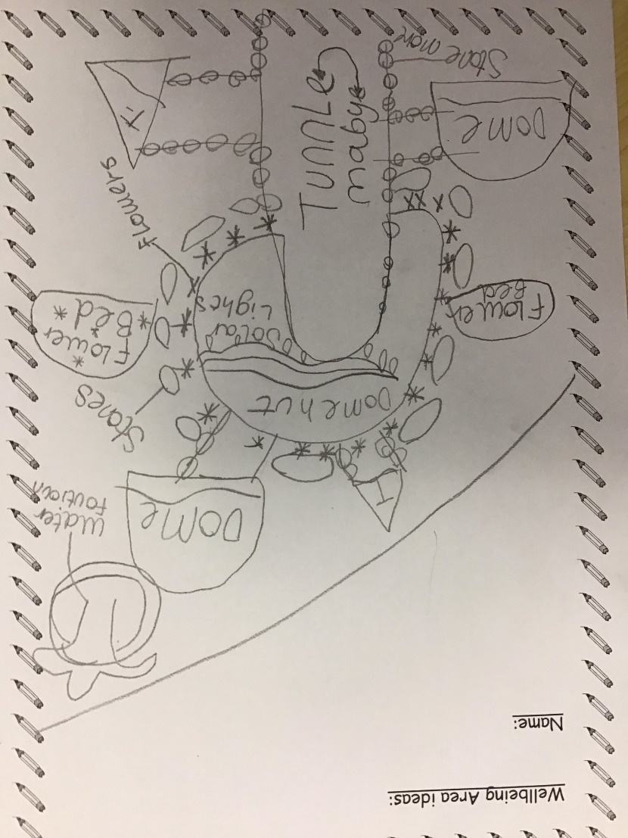
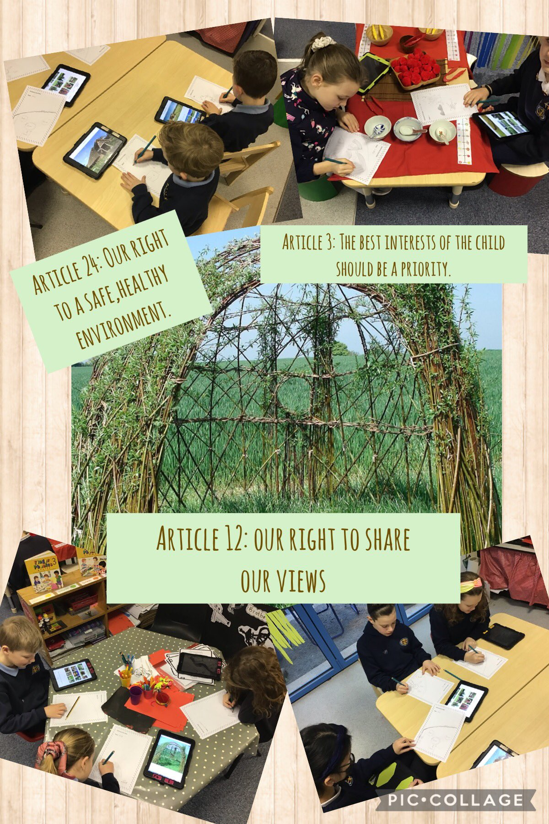
Feb 16th 2022
- Why do we need safe spaces?
- Who will it be for? Everyone in the class including grown ups.
- Have to be respectful.
- Talked about a safe space to go outdoors. Agreed on a willow village.
- Developed designs.
- Sent to local business to ask for support.

