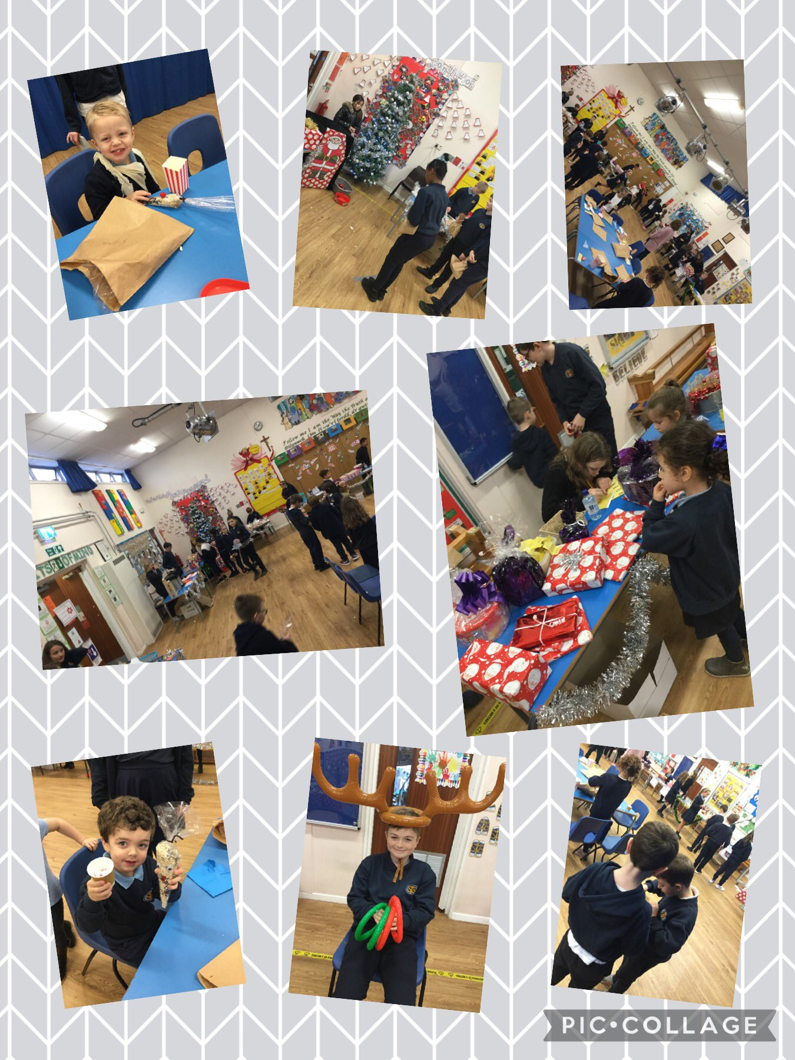
- An outstanding amount of £820.89 was raised at our Christmas Fayre today. THANK YOU to all of our children, families and staff for a great team effort. Diolch yn fawr to our School Council for the weeks of planning and preparation.

